CS 340

7-2 Project Two Submission

SNHU

Omid Howrang

Date

**About the application**

The application is a dashboard web application that follows the MVC structure that gives an analysis of data from an animal shelter.

**Prerequisites**

You need to have the following software installed to run the project.

* Python
* MongoDB

**Motivation to use MongoDB**

Since Mongo offers a simple setup of the databases from CSV documents and a Python-friendly interface, it was chosen expressly for this program. Although Python may use SQL-like database tools, the syntax is so dissimilar that switching between them can be difficult. When performing the fundamental CRUD operations of a dataset using Python, the tools in a SQL database are substantially more complicated than those in a Mongo DB.

**Why Dash**

Dash was chosen as the dashboard construction tool because of its dynamic features. Dash is a program that uses react JavaScript and offers a remarkably responsive foundation. HTML Dash tags are used in Dash to manage component deliverables. Updates to any of the target inputs provided in the program closures method are then made in accordance with the Python module's programmable commands.

**Getting started**

The application went through various steps to have it fully set up.

First, import the dataset into the mongo folder and start the MongoDB services.

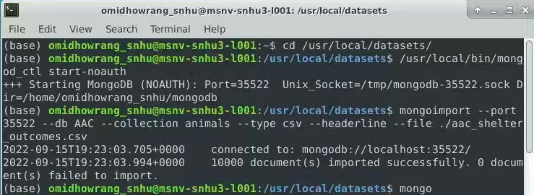

The second step was to authenticate the user of MongoDB by creating a user and setting the password.

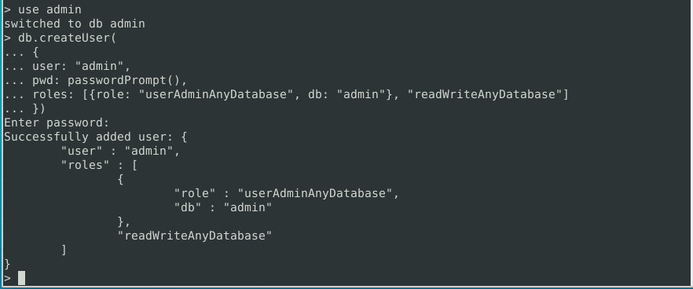

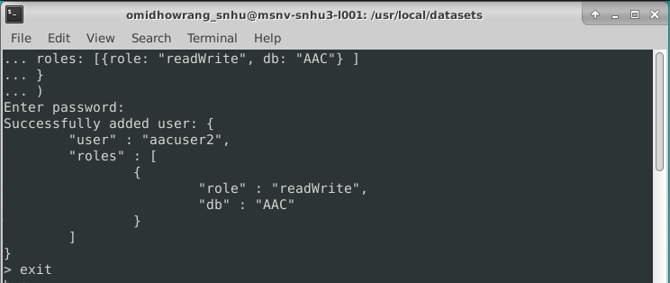

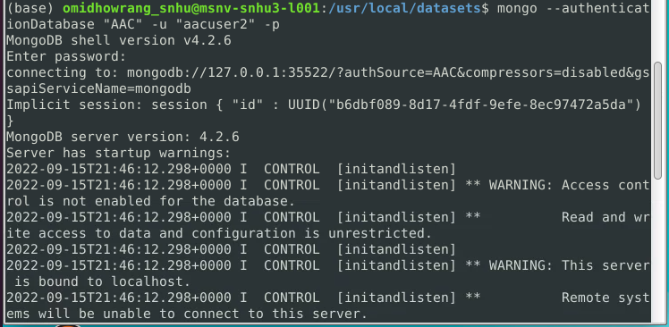

The third step was to write the CRUD functions in python that would perform the CRUD operations to the dataset using MongoDB.

**CRUD functionality test execution**

Create and read

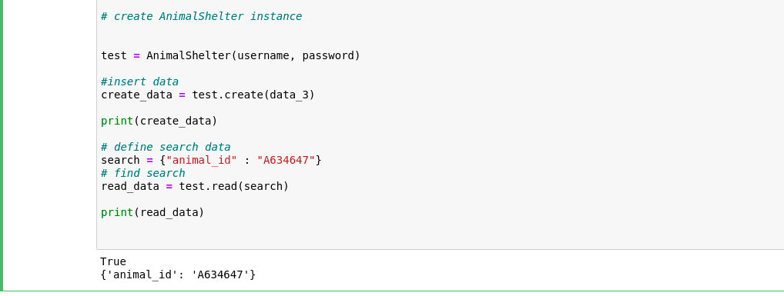

Delete and update

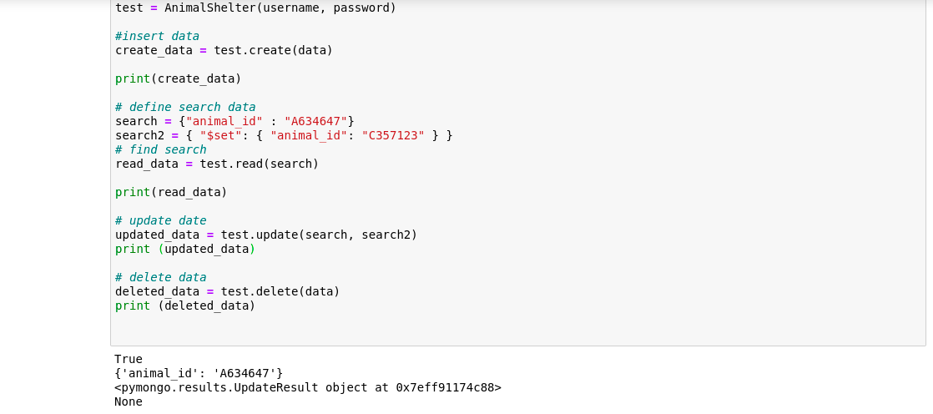

After the data has been fetched, a separate python code was written to display the data on the dashboard and provide the CRUD functionalities on the user interface.

**Challenges encountered**

Throughout the project, I encountered a number of challenges even though they were not many. I had a challenge with setting up MongoDB to accept the password in python code. I researched on the internet and found the updates about password settings and used the urllib.parse to avoid the password error while setting up the connection.

The Dashboard

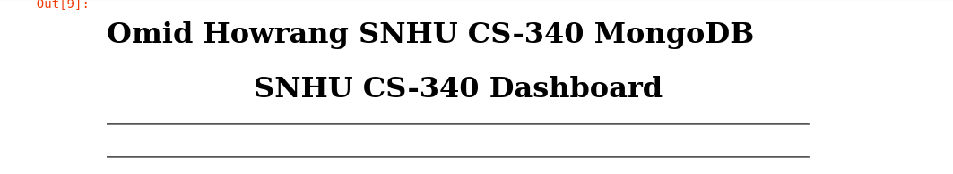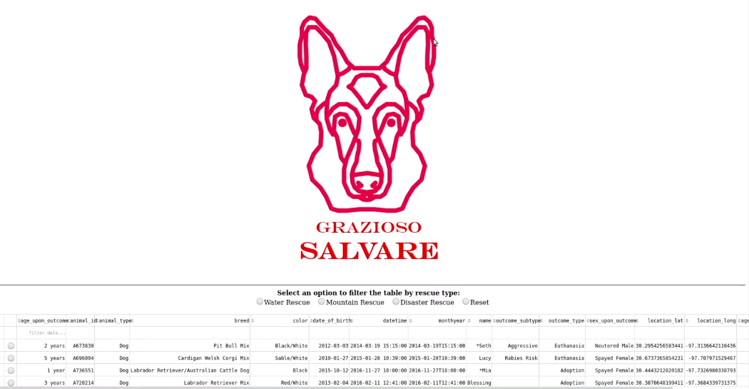

Water Rescue

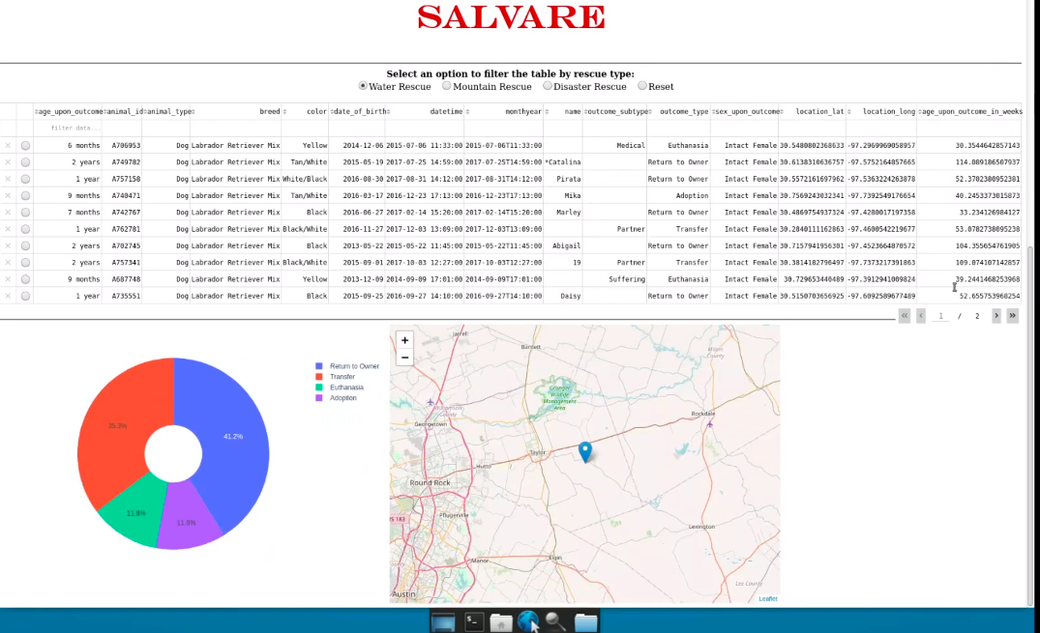

Mountain or Wilderness rescue

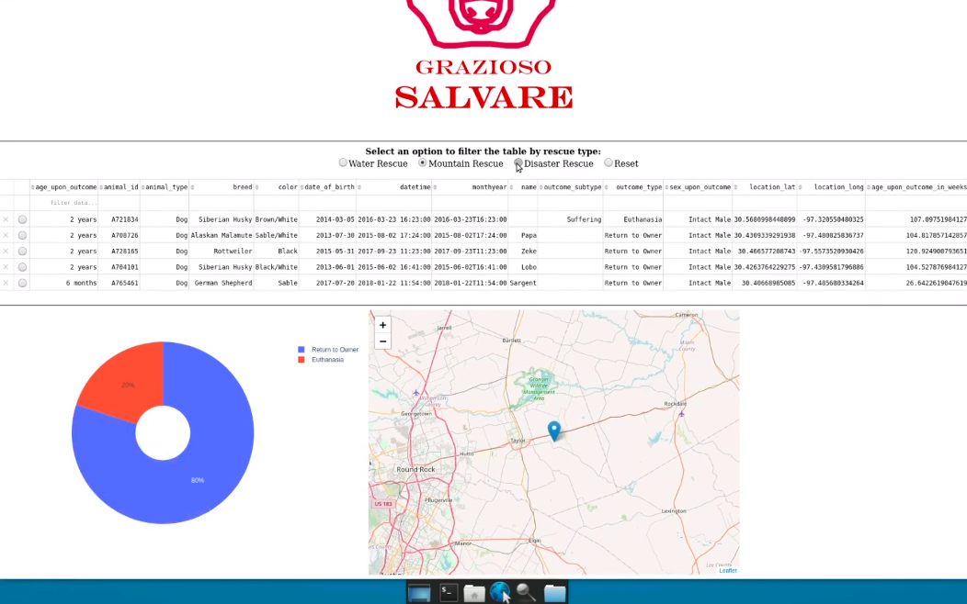

Desert or individual tracking 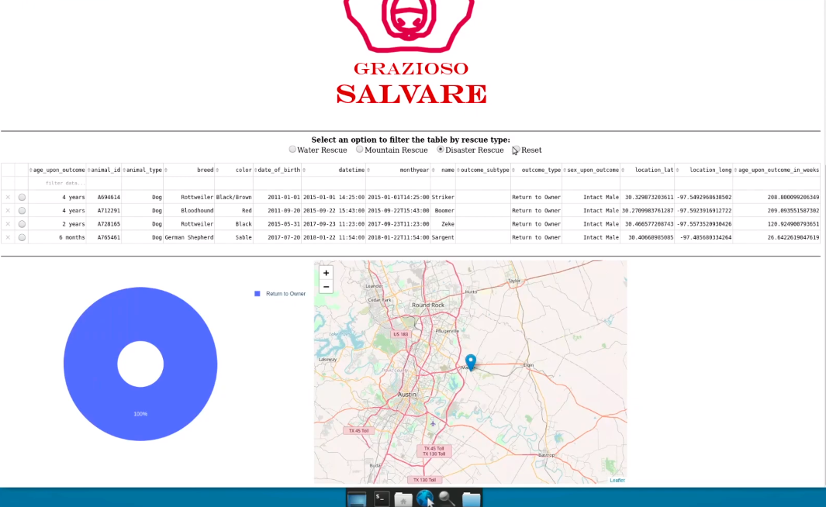



Reset

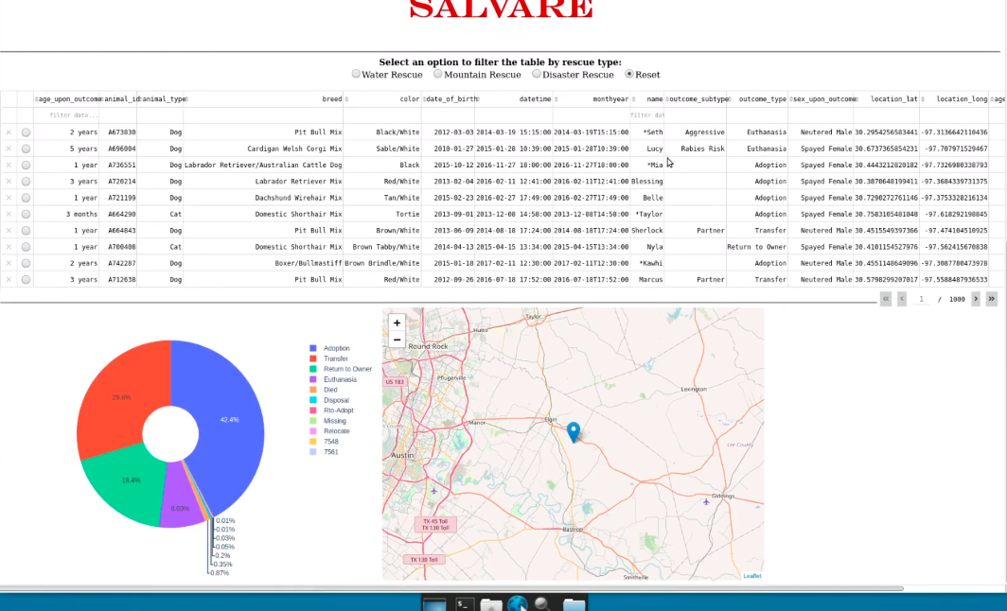

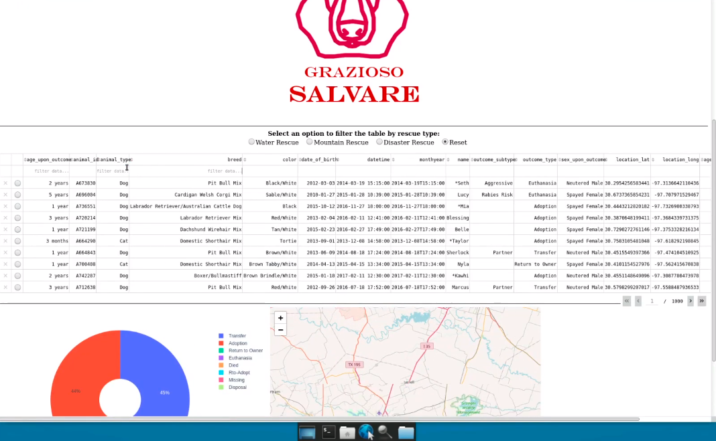

Links

Dash - <https://pypi.org/project/dash/>

MongoDB - <https://docs.mongodb.com/manual/installation/>

Panda - <https://pandas.pydata.org/pandas-docs/stable/getting_started/install.html>

Plotty- <https://www.journaldev.com/19692/python-plotly-tutorial#:~:text=Installation.%20To%20install%20plotly%2C%20open%20a%20terminal%20window,to%20install%20to%20collect%20dependencies%20and%20download%20them%3A>